

Functional Specification Documentation

For
Automation Landed Cost

Version No.: 1.1
Date: 28th March 2017

Table of Content
1. Overview Details 3
1.1 Objective 3
2. Table Setup (User Defined Table) 0
3. Requirement 2
Reports 6
Report #1 – Landed Cost Contract Account Reconciliation Report 6
Report #2 – Landed Cost with COS account report 6
Report #3 – Freight Percentage 6

1. Overview Details

1.1 Objective

Description
- When a Goods Receipt PO (GRPO) is added into SAP, a Landed Cost document will be created automatically for upon GRPO creation.
- For Actual landed cost, user need to create manually at Landed cost module.

Note:
ALC = Actual Landed Cost
ELC = Estimated landed cost

Pre-requisition

The automation landed cost will be activating only when below condition is match:
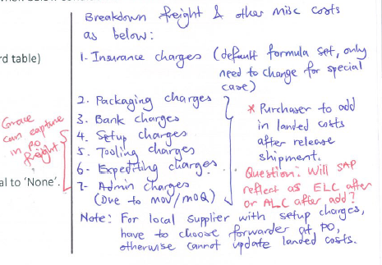
- Below table need to be configure firs:

  - Landed Cost – Setup (SAP Standard table)
  - Landed Cost Component
  - Courier Table
  - Forwarder table
  - Fuel Surcharge Table
  - Inco Table
  - Dimension Surcharge Table
  - Zone Table

- At GRPO screen, Landed Cost Method not equal to ‘None’.

Yes
Yes

2. Table Setup (User Defined Table)

- Landed Cost Component Table
If the component exists in this table, will be auto flow into Landed Cost.

 | Component | Type
 | Freight Charges (ELC) | ELC
 | Insurance Charge (ELC | ELC

- Courier Table
Add 2 more columns for validity date (From Date, To Date)

Forwarder code (BP code) | Weight (kg) | Zone 1 | Zone 2 | Zone 3 | Zone 4 | Zone 7 | From Date | To Date
DHL | 0.5 | 14.33 |  |  |  |  | 01/01/2015 | 31/12/2015
DHL | 1.0 | 15.58 |  |  |  |  | 01/10/2015 | 31/12/2015
DHL | 2.0 |  |  |  |  | 49.24 | 01/10/2015 | 31/12/2015
DHL Express | 15.0 | 67.21 | 98.09 | 101.28 | 109.69 |  | 01/01/2015 | 31/12/2015
DHL Express | 15.5 | 68.87 | 98.61 | 104.47 | 112.13 |  | 01/10/2015 | 31/12/2015
DHL Express | 16.0 | 70.63 | 99.13 | 107.66 | 114.57 |  | 01/10/2015 | 31/12/2015
DHL Express | 69.0 | 2.92 | 2.88 | 3.43 | 5.22 |  | 01/10/2015 | 31/12/2015
DHL Express | 99.0 | 2.27 | 2.85 | 3.03 | 4.33 |  | 01/10/2015 | 31/12/2015
DHL Express | 229.0 | 2.14 | 2.75 | 2.97 | 4.08 |  | 01/10/2015 | 31/12/2015
DHL Express | 230.0 | 2.14 | 2.75 | 2.97 | 4.08 |  | 01/10/2015 | 31/12/2015
DHL Express | 249.0 | 2.14 | 2.75 | 2.97 | 4.08 |  | 01/10/2015 | 31/12/2015
DHL Express | 250+ | 1.99 | 2.71 | 2.84 | 3.72 |  | 01/10/2015 | 31/12/2015
- Forwarder Table (always compare “minimum” and “flat * weight” which higher then plus basic)

Forwarder | Country | Port | Inco Terms | Cur | Component | By Amount | By KG  /NET | Weight | Min | Flat | Basic | From Date | To Date
DHL Global | UK | ALL | ALL | GBP | Freight | Amount | KG | 0.00 | 20.00 | 1.20 | 0.00 | 01/01/2015 | 31/12/2015
DHL Global | UK | ALL | ALL | GBP | Fuel | Amount | KG | 0.00 | 0.00 | 1.50 | 0.00 | 01/10/2015 | 31/12/2015
DHL Global | UK | ALL | ALL | GBP | Handling | Amount | KG | 0.00 | 20.00 | 0.20 | 32.00 | 01/10/2015 | 31/12/2015
DHL Global | UK | ALL | ALL | GBP | Export Fee | Amount | KG | 0.00 | 15.00 | 0.00 | 0.00 | 01/10/2015 | 31/12/2015
DHL Global | UK | ALL | ALL | GBP | X-Ray | Amount | KG | 0.00 | 8.00 | 0.09 | 0.00 | 01/10/2015 | 31/12/2015
DHL Global | UK | ALL | ALL | SGD | Local Handling | Amount | KG | 0.00 | 60.00 | 0.20 | 0.00 | 01/10/2015 | 31/12/2015
Logwin | Swiss | 2 | ALL | CHF | Pick Up | Amount | Net | 20.00 | 0.00 | 0.00 | 48 | 01/10/2015 | 31/12/2015
Logwin | Swiss | 2 | ALL | CHF | Pick Up | Amount | Net | 50.00 | 0.00 | 0.00 | 53 | 01/10/2015 | 31/12/2015
Logwin | Dubai | Shanja | ALL | USD | Freight | Amount | KG | 45.00 | 60.00 | 2.00 | 0.00 | 01/10/2015 | 31/12/2015
Logwin | Dubai | Shanja | ALL | USD | Freight | Amount | KG | 100.00 | 60.00 | 1.55 | 0.00 | 01/10/2015 | 31/12/2015
Logwin | Germany | All | ALL | SGD | Local Handling | Amount | KG | 0.00 | 60.00 | 0.25 | 0.00 | 01/10/2015 | 31/12/2015
Logwin | Germany | CGN | EXW | EUR | Import Air Freight | Amount | KG | 0.00 | 25.00 | 1.05 | 0.00 | 01/10/2015 | 31/12/2015
Logwin | Germany | CGN | FOB | EUR | Fuel | Amount | KG | 0.00 | 0.00 | 0.40 | 0.00 | 01/10/2015 | 31/12/2015
Logwin | Germany | CGN | FOB | EUR | Security | Amount | KG | 0.00 | 0.00 | 0.08 | 0.00 | 01/10/2015 | 31/12/2015
Logwin | Germany | CGN | FOB | EUR | AES | Amount | KG | 0.00 | 0.00 | 0.00 | 8.00 | 01/10/2015 | 31/12/2015
Logwin | Germany | CGN | FOB | EUR | Ex-work charges | Amount | KG | 0.00 | 0.00 | 0.20 | 25.00 | 01/10/2015 | 31/12/2015

Delete Supplier Code and Add Inco Terms

Compare 2 columns and take whichever is higher. + Basic
(Min) or (Flat * Weight) + Basic

By Net: Directly take the amount (No need multiply by kg)
By KG : Weight (Total weight from packaging details) * Flat and compare to minimum then take higher

- Fuel Surcharge Table

Courier | By Amount/Percent | By KG /Net | Rate | Month  (expiry month)
DHL Express | Percent | KG | 11.00 | October 2015 | 11% x Weight  (Weight x Zone from Courier table) x 11%
FedEx | Amount | KG | 15.00 | October 2015 | $15 x weight  (Weight x Zone from Courier table) x $15
TNT | Amount | Net | 100 | October 2015 | $100
DHL | Percent | Net | 12.00 | October 2015

To decide based on Amount/Percent and KG/Net: Each courier will use one method only, so can use the BP code to decide

Delete “Country Column” in Fuel Surcharges Table
Not required for By Percent and By Net.

- Inco Table (Insurance)

Inco-term code | PO Print Out Description | CFR value | Insurance rate
EXW | EXW | 1.1 | 0.00025 | GRPO Total amount before GST * CRF value * Insurance rate
CIF | CIF | 0 | 0
FCA-Overseas | FCA | 1.1 | 0.00025
FCA-Local | FCA | 0 | 0
FOB | FOB | 1.1 | 0.00025

*** To be confirmed: Is GRPO total is before GST or after GST

- Dimension Surcharge Table

Forwarder/Courier | Currency | Extra Charge | Weight | Weight Surcharge | Dimension | Dimension Surcharge
DHL Express | SGD | Yes | 70 | 45 | 120 | 40
TNT | SGD |  | 70 | 41 | 120 | 41
DHL Global | GBP |  | 70 | 40 | 120 | 0
Logwin | SGD |  | 70 | 40 | 120 | 40
Charge only for the overweight.

- Zone Table / make use of Country table

Country | DHL | TNT | FedEx
Singapore | 1 | 1 | 2
Australia | 3 | 3

Country | Forwarder | Zone
Singapore | DHL | 1
Austrilia | DHL | 2
Singapore | FedEx | 1
Japan | DHL Express | 4

Requirement

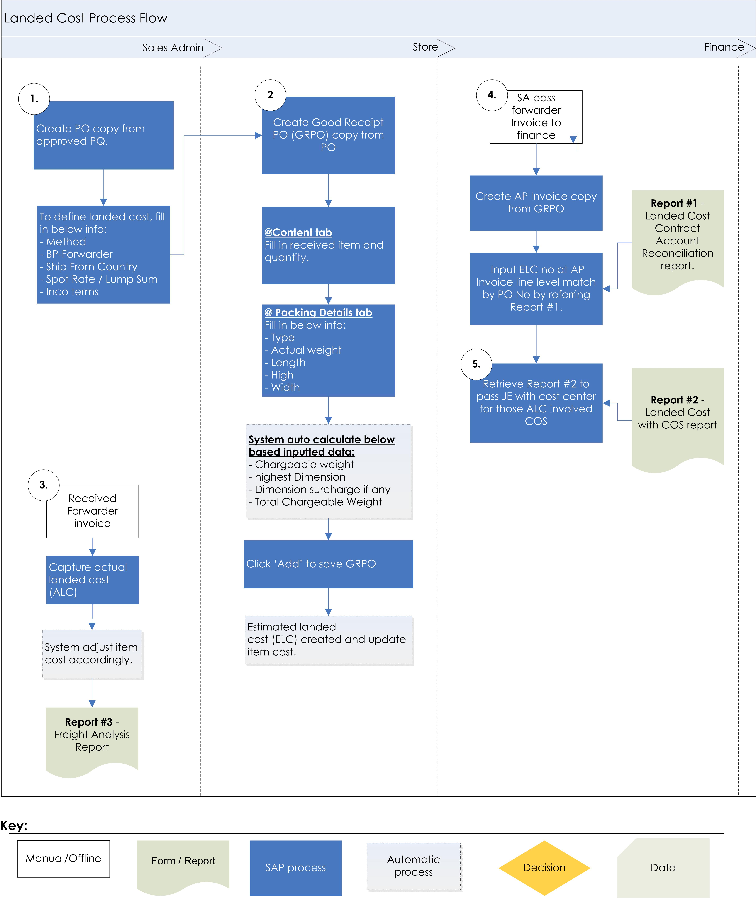
Automation will start from here.
- When store create GRPO copy from PO, below information will auto populate from PO except ‘Total Chargeable Weight’ and Spot Rate/Lump Sum need to input upon receiving.

Create below list of UDF in marketing document header level:
Method | Courier | UDF (Drop down list >> Courier, Forwarder, Spot Rate, Lump Sum, None)
BP – forwarder (UDF) | DHL Express | UDF (Choose From List - BP List)
Ship From Country | UK | UDF (from country) – pick from BP Master default ship to address country code
Port | Shanja | UDF – Drop down list from forwarder table based on Country
Zone | 1 | UDF - FS based zone table
Total Chargeable Weight | 229 | System calculate from GRPO grid
Spot Rate / Lump Sum | (Amount column) | UDF – Mandatory if Method = Spot Rate / Lump Sum
Inco terms | EXW | UDF – Default pick from BP Master Inco terms UDF based on select BP – forwarder.

Cost Calculation Method

Method = Courier - If Method selected “Courier”, the following formula will be applied:

[Courier Table + Fuel Surcharge Table + Inco Table + Dimension Surcharge table + Fuel Surcharge x Total Dimension Surcharge]
[Courier Table + Dimension Surcharge Table (if any)] + Fuel Surcharge Table+ Inco Table

Method = Forwarder - If Method selected “Forwarder”, the following formula will be applied:

[Forwarder Table + Inco Table + Dimension Surcharge table (if any)]

Method = Spot Rate - If Method selected “Spot Rate”, the following formula will be applied:

[GRPO Sport Rate UDF * GRPO Weight (kg)] + Fuel Surcharge Table + Inco Table + Dimension Surcharge table + Fuel Surcharge apply to Dimension Surcharge

[GRPO Spot Rate UDF * GRPO Weight (kg) (Total weight from packaging details)] + [Dimension Surcharge table (if any) + Fuel Surcharge Table] + Inco Table

Fuel Surcharge table formula: [GRPO Spot rate * Total Weight from packaging details + dimension surcharge table(if any)] * Fuel surcharge

Method = Lump sum - If Method selected “Lump sum”, the following formula will be applied:

[GRPO Spot Rate UDF] (considered as lump sum freight amount) (for sea freight)

Method = None - If Method selected “None”, no landed cost document will be created.

- Formula of Volumetric weight:

Formula of Volumetric weight:
Courier >> Length x height x width / 5000

Forwarder >> based on country code
Length x height x width / 6000
Length x height x width / 3000

- Below will be new tab – Packing Details to be created for Store to input Actual Weight and dimension by packaging type.

Packing Details (after Attachment tab) – will be at Grid Format as below:
Take weight whichever is higher

No | Packaging  Type | Actual Weight (Kg) | Chargeable weight (Kg) | Length | High | Width | Highest Dimension | Dimension Surcharge
1 | Pallet | 75 | 156 | 120 | 50 | 130 | 130 | 85
2 | Pallet | 67 | 65 | 30 | 125 | 40 | 125 | 40
3 | Carton | 3 | 6 | 20 | 30 | 50 | 50 | 0

Fields Explanation:
No | Field Name | Control type | Business Rules
1. | Packaging type | Drop Down | Options: (can be add in future)  - Pallet  - Carton  - Box
2. | Actual Weight | Text Box | User Input
3. | Chargeable Weight | Text Box | System auto pick from either Actual weight or Volumetric weight, whichever is higher.  Formula of Volumetric weight:  Courier >> Length x height x width / 5000  Forwarder >> based on country code  Length x height x width / 6000  Length x height x width / 3000  - 3000 is only for Country: Switzerland, Forwarder: Logwin.  - For the rest of the countries and forwarders, it is 6000.
4. | Length | Text Box | User Input
5. | Height | Text Box | User Input
6. | Width | Text Box | User Input
7. | Highest Dimension | Text Box | System auto pick from either Length or High or Width whichever is higher.
8. | Dimension Surcharge | Text Box | - One time charge per pallet, if one pallet exceeds both weight and dimension, then charge one time only whichever is higher between weight surcharge or dimension surcharge.  - Charge only if exceed the maximum.  - If Extra Charge in Surcharge table = Yes, both Weight and Dimension exceed maximum, Dimension surcharge will be Weight surcharge + Dimension

- Calculation for the cost and add into Landed Cost. This calculation will be hidden to user and auto calculates backend then saves into Landed Cost.

Method : Courier (Scenario 1)
USD Exchange rate : 1.4

Courier Calculation:
Match the BP Code, Weight and Zone details with Courier Table:
BP: DHL Express, Zone 4
Weight 229.3 kg (Round up to the nearest number) >= 249 (line 10) then
Calculation is (230 * 4.08) = 938.4

Dimension Surcharge Calculation:
Check overweight or not in Dimension Surcharge Table:
This dimension surcharge is applicable only for overweight
BP: DHL Express
Weight 229.3 kg then
Calculation is (45 + 40) = 85

Fuel Surcharge Calculation:
Match the BP Code with Fuel Surcharge Table:
BP: DHL Express, Zone 4
Weight 229.3 kg then
Calculation is (230 * 4.08) *11% = 103.22

Inco Calculation (Insurance):
Match the Inco Terms with Inco Table:
GRPO Total amount before GST * CRF value * Insurance rate
Inco Terms: EXW , GRPO Total Amount before GST: 1000
Calculation is (1000 * 1.1 * 0.00025) = 0.28

 |  | Minimum | Flat | Flat Amount | Whichever is higher | Plus Basic | After convert SGD
Courier |  | 938.40 |  |  |  |  | 938.40
Dimension Surcharge |  | 85.00 |  |  |  |  | 85.00
Fuel Surcharge |  | 103.22 |  |  |  |  | 103.22
 |  |  |  |  |  |  | 1126.62
Insurance* |  | = USD 1000(total amt of GRPO) x 1.1 x 0.00025 = USD 0.28 |  |  |  |  | 0.39
Total Estimated Landed Cost to be created |  |  |  |  |  |  | 1127.01
Total Estimated Landed Cost of example in above = SGD 1127.01

The Breakdown cost will be as below in SAP screen:
Insurance: 0.39
Freight Charges: 938.49 + 85.00 + 103.22 = 1126.62

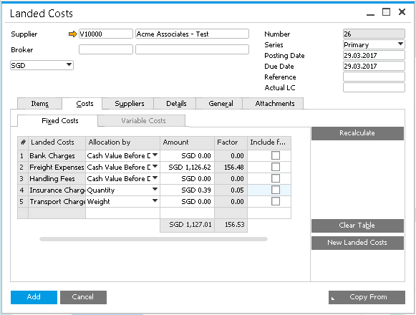

Method: Courier (Scenario 2)
USD Exchange rate : 1.4

Courier Calculation:
Match the BP Code, Weight and Zone details with Courier Table:
BP: DHL Express, Zone 4
Weight 15.2 kg >= 112.13 (line 5) then
Calculation is (15.5 * 112.13) = 1738.02

Dimension Surcharge Calculation:
Check overweight or not in Dimension Surcharge Table:
This dimension surcharge is applicable only for overweight
BP: DHL Express
Weight 15.2 kg then
Calculation is (0) = 0

Fuel Surcharge Calculation:
Match the BP Code with Fuel Surcharge Table:
BP: DHL Express, Zone 4
Weight 15.2 kg then
Calculation is (15.5 * 112.13) *11% = 191.18

Inco Calculation (Insurance):
Match the Inco Terms with Inco Table:
GRPO Total amount before GST * CRF value * Insurance rate
Inco Terms: EXW , GRPO Total Amount before GST: 1000
Calculation is (1000 * 1.1 * 0.00025) *11% = 0.28

 |  | Minimum | Flat | Flat Amount | Whichever is higher | Plus Basic | After convert SGD
Courier |  | 1738.02 |  |  |  |  | 1738.02
Dimension Surcharge |  | 0 |  |  |  |  | 0
Fuel Surcharge |  | 191.18 |  |  |  |  | 191.18
 |  |  |  |  |  |  | 1929.2
Insurance* |  | = USD 1000(total amt of GRPO) x 1.1 x 0.00025 = USD 0.28 |  |  |  |  | 0.39
Total Estimated Landed Cost to be created |  |  |  |  |  |  | 1929.59

Total Estimated Landed Cost of example in above = SGD 1929.59

The Breakdown cost will be as below in SAP screen:
Insurance: 0.39
Freight Charges: 1738.02 + 0 + 191.18 = 1929.2

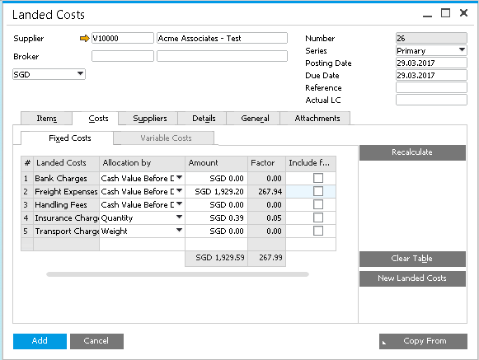

Method: Courier (Scenario 3)
USD Exchange rate: 1.4

Courier Calculation:
Match the BP Code, Weight and Zone details with Courier Table:
BP: DHL Express, Zone 4
Weight 270 kg >= 112.13 (line 5) then
Calculation is (270 * 3.72) = 1004.4

Dimension Surcharge Calculation:
Check overweight or not in Dimension Surcharge Table:
This dimension surcharge is applicable only for overweight
BP: DHL Express
Weight 270 kg then
Calculation is (45+40) = 85

Fuel Surcharge Calculation:
Match the BP Code with Fuel Surcharge Table:
BP: DHL Express, Zone 4
Weight 270 kg then
Calculation is (270 * 3.72) *11% = 110.48

Inco Calculation (Insurance):
Match the Inco Terms with Inco Table:
GRPO Total amount before GST * CRF value * Insurance rate
Inco Terms: EXW , GRPO Total Amount before GST: 1000
Calculation is (1000 * 1.1 * 0.00025) *11% = 0.28

 |  | Minimum | Flat | Flat Amount | Whichever is higher | Plus Basic | After convert SGD
Courier |  | 1004.4 |  |  |  |  | 1004.4
Dimension Surcharge |  | 85 |  |  |  |  | 85.00
Fuel Surcharge |  | 110.48 |  |  |  |  | 110.48
 |  |  |  |  |  |  | 1199.88
Insurance* |  | = USD 1000(total amt of GRPO) x 1.1 x 0.0025 = USD 0.28 |  |  |  |  | 0.39
Total Estimated Landed Cost to be created |  |  |  |  |  |  | 1200.27

Total Estimated Landed Cost of example in above = SGD 1200.27

The Breakdown cost will be as below in SAP screen:
Insurance: 0.39
Freight Charges: 1004.4 + 85.00 + 110.48 = 1199.88

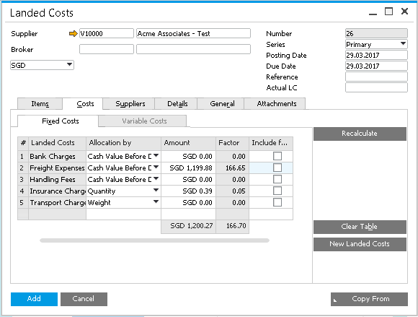

Method: Forwarder (Scenario 1)
GBP Exchange rate : 2.1
USD Exchange rate : 1.4

Forwarder Calculation:
BP: DHL Global, Weight 228.2 kg
Check the weight in the setup table. If weight in the setup table is 0 then
Calculation is
Freight: Min= 20, Flat: 1.2 * 229= 274.8, Basic =0
Fuel: Min= 0, Flat: 1.5 * 229= 343.5, Basic =0
Handling: Min= 20, Flat: 0.20 * 229= 45.8, Basic =32
Export Fee: Min= 15, Flat: 0 * 229= 0, Basic =0
X-Ray: Min= 8, Flat: 0.09 * 229= 20.61, Basic =0
Local Handling: Min= 60, Flat: 0.20 * 229= 45.8, Basic =0

Dimension Surcharge Calculation:
Check overweight or not in Dimension Surcharge Table:
This dimension surcharge is applicable only for overweight
BP: DHL Global, Weight 228.2 kg.
Calculation is (40) = 40

Inco Calculation (Insurance):
Match the Inco Terms with Inco Table:
GRPO Total amount before GST * CRF value * Insurance rate
Inco Terms: EXW , GRPO Total Amount before GST: 1000
Calculation is (1000 * 1.1 * 0.00025) *11% = 0.28

 |  | Minimum | Flat | Flat Amount | Whichever is higher | Plus Basic | After convert SGD
Freight |  | 20.00 | 1.20 | 274.80 | 274.80 | 0.00 | 577.08
Fuel |  | 0.00 | 1.50 | 343.5 | 343.5 | 0.00 | 721.35
Handling |  | 20.00 | 0.20 | 45.8 | 45.8 | 32.00 | 163.38
Export Fee |  | 15.00 | 0.00 | 0.00 | 15.00 | 0.00 | 31.50
X-Ray |  | 8.00 | 0.09 | 20.61 | 20.61 | 0.00 | 43.28
Local Handling |  | 60.00 | 0.20 | 45.8 | 60.00 | 0.00 | 60.00
 |  |  |  |  |  |  | 1596.59
Insurance* |  | = USD 1000(total amt of GRPO) x 1.1 x 0.0025 = USD 0.28 |  |  |  |  | 0.39
Dimension |  | 40 |  |  |  |  | 84.00
Total Estimated Landed Cost to be created |  |  |  |  |  |  | 1680.98

Total Estimated Landed Cost of example in above = SGD 1680.98

The Breakdown cost will be as below in SAP screen:
Insurance: 0.39
Freight Charges: 577.08 + 721.35 + 163.38 + 31.50 + 43.28 + 60 + 84 = 1680.59

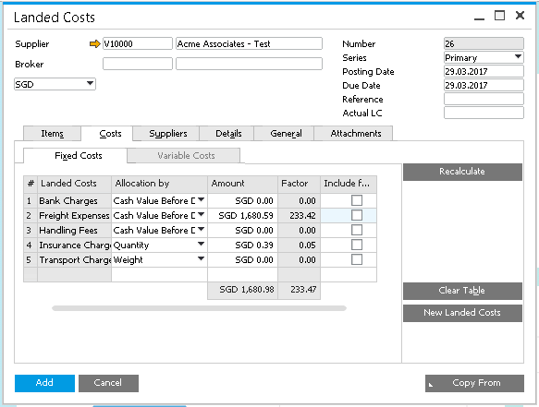

Method: Forwarder (Scenario 2)
EUR Exchange rate: 1.51
USD Exchange rate: 1.4

Forwarder Calculation:
BP: Logwin, Weight 228.3 kg, Country: Germany, Port: CGN, Inco Terms: EXW
Calculation is
Import Air Freight: Min= 25, Flat: 1.05 * 229= 240.45, Basic =0
Local Handling: Min=60, Flat: 0.25 * 229 = 57.25, Basic =0

Dimension Surcharge Calculation:
Check overweight or not in Dimension Surcharge Table:
This dimension surcharge is applicable only for overweight
BP: Logwin, Weight 228.3 kg
Calculation is (40) = 40

Inco Calculation (Insurance):
Match the Inco Terms with Inco Table:
GRPO Total amount before GST * CRF value * Insurance rate
Inco Terms: EXW , GRPO Total Amount before GST: 1000
Calculation is (1000 * 1.1 * 0.00025) *11% = 0.28

 |  | Minimum | Flat | Flat Amount | Whichever is higher | Plus Basic | After convert SGD
Import Air Freight |  | 25.00 | 1.05 | 240.45 | 240.45 | 0.00 | 363.08
Local Handling |  | 60.00 | 0.25 | 57.25 | 60.00 | 0.00 | 60.00
 |  |  |  |  |  |  | 423.08
Insurance* |  | = USD 1000(total amt of GRPO) x 1.1 x 0.0025 = USD 0.28 |  |  |  |  | 0.39
Dimension |  | 40 |  |  |  |  | 40.00
Total Estimated Landed Cost to be created |  |  |  |  |  |  | 463.47

Total Estimated Landed Cost of example in above = SGD 463.47

The Breakdown cost will be as below in SAP screen:
Insurance: 0.39
Freight Charges: 423.08 + 40.00 = 463.08

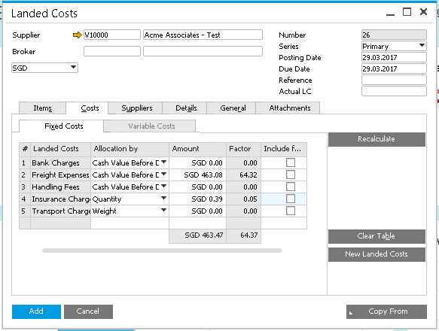

Method : Forwarder (Scenario 3)
Swiss Exchange rate : 1.45
USD Exchange rate : 1.4

Forwarder Calculation:
BP: Logwin, Weight 30 kg, Country: Swiss, Port: 2
Check the weight in the setup table. Take the rate based on the weight
Calculation is 53

Dimension Surcharge Calculation:
Check overweight or not in Dimension Surcharge Table:
This dimension surcharge is applicable only for overweight
BP: Logwin, Weight: 30kg
Calculation is (0) = 0

Inco Calculation (Insurance):
Match the Inco Terms with Inco Table:
GRPO Total amount before GST * CRF value * Insurance rate
Inco Terms: EXW , GRPO Total Amount before GST: 1000
Calculation is (1000 * 1.1 * 0.00025) *11% = 0.28

 |  | Minimum | Flat | Flat Amount | Whichever is higher | Plus Basic | After convert SGD
Pick up |  | 0 | 0 | 0 | 0 | 53.00 | 74.2
 |  |  |  |  |  |  | 74.2
Insurance* |  | = USD 1000(total amt of GRPO) x 1.1 x 0.0025 = USD 0.28 |  |  |  |  | 0.41
Dimension |  | 0 |  |  |  |  | 0.00
Total Estimated Landed Cost to be created |  |  |  |  |  |  | 74.61

Total Estimated Landed Cost of example in above = SGD 74.61

The Breakdown cost will be as below in SAP screen:
Insurance: 0.41
Freight Charges: 74.200 = 74.2

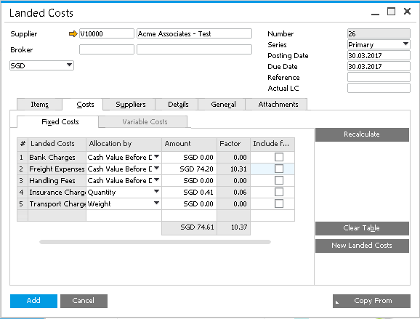

Method: Forwarder (Scenario 4)
CHF Exchange rate : 1.4

Forwarder Calculation:
BP: Logwin, Weight 30 kg, Country: Dubai, Port: Shanja
Calculation is (30 * 2) = 60

Dimension Surcharge Calculation:
Check overweight or not in Dimension Surcharge Table:
This dimension surcharge is applicable only for overweight
Calculation is (0) = 0

Inco Calculation (Insurance):
Match the Inco Terms with Inco Table:
GRPO Total amount before GST * CRF value * Insurance rate
Inco Terms: EXW , GRPO Total Amount before GST: 1000
Calculation is (1000 * 1.1 * 0.00025) *11% = 0.28

 |  | Minimum | Flat | Flat Amount | Whichever is higher | Plus Basic | After convert SGD
Freight |  | 0.00 | 2 | 60 | 60 | 0.00 | 84.00
 |  |  |  |  |  |  | 84.00
Insurance* |  | = USD 1000(total amt of GRPO) x 1.1 x 0.0025 = USD 0.28 |  |  |  |  | 0.39
Dimension |  | 0 |  |  |  |  | 0.00
Total Estimated Landed Cost to be created |  |  |  |  |  |  | 84.39
Total Estimated Landed Cost of example in above = SGD 84.39

The Breakdown cost will be as below in SAP screen:
Insurance: 0.39
Freight Charges: 84 + 0 = 84

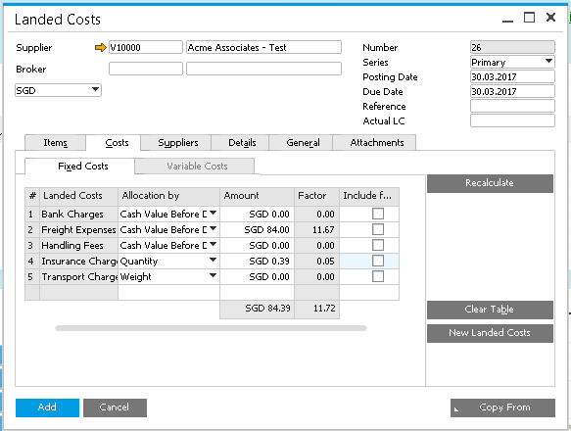

Method : Forwarder (Scenario 5)
CHF Exchange rate : 1.4

Forwarder Calculation:
BP: Logwin, Weight 229 kg, Country: Dubai, Port: Shanja
Calculation is (229 * 1.55) = 354.95, min= 60, basic=0

Dimension Surcharge Calculation:
Check overweight or not in Dimension Surcharge Table:
This dimension surcharge is applicable only for overweight
BP: Logwin
Calculation is (40) = 40

Inco Calculation (Insurance):
Match the Inco Terms with Inco Table:
GRPO Total amount before GST * CRF value * Insurance rate
Inco Terms: EXW , GRPO Total Amount before GST: 1000
Calculation is (1000 * 1.1 * 0.00025) *11% = 0.28

 |  | Minimum | Flat | Flat Amount | Whichever is higher | Plus Basic | After convert SGD
Freight |  | 0.00 | 1.55 | 354.95 | 354.95 | 0.00 | 496.93
 |  |  |  |  |  |  | 496.93
Insurance* |  | = USD 1000(total amt of GRPO) x 1.1 x 0.0025 = USD 0.28 |  |  |  |  | 0.39
Dimension |  | 40 |  |  |  |  | 40.00
Total Estimated Landed Cost to be created |  |  |  |  |  |  | 537.32

Total Estimated Landed Cost of example in above = SGD 537.32

The Breakdown cost will be as below in SAP screen:
Insurance: 0.39
Freight Charges: 496.93 + 40.00 = 536.93

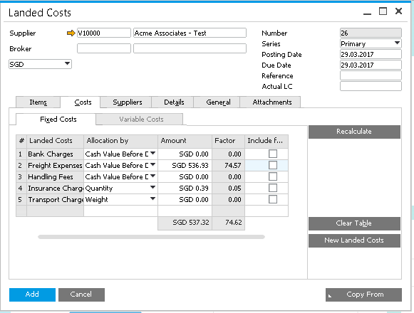

Method: Spot Rate (Scenario 1)
USD Exchange rate: 1.4

BP: DHL Express, GRPO Spot Rate: 15, GRPO weight kg: 228.2 kg

Dimension Surcharge Calculation:
Check overweight or not in Dimension Surcharge Table:
This dimension surcharge is applicable only for overweight
BP: DHL Express
Calculation is (45 + 40) = 85

Fuel Surcharge Calculation:
Calculation is (15 * 229 + 85) * 11% = 387.20

Inco Calculation (Insurance):
Match the Inco Terms with Inco Table:
GRPO Total amount before GST * CRF value * Insurance rate
Inco Terms: EXW , GRPO Total Amount before GST: 1000
Calculation is (1000 * 1.1 * 0.00025) *11% = 0.28

Total Calculation
Freight calculation: (15 * 229) + (85 + 387.20) = 3907.20

 |  | After convert SGD
Freight | 3907.2 | 3907.2
Insurance* | 0.28 | 0.39
Total Estimated Landed Cost to be created |  | 3907.59

Total Estimated Landed Cost of example in above = SGD 3907.59

The Breakdown cost will be as below in SAP screen:
Insurance: 0.39
Freight Charges: 3907.2 = 3907.2

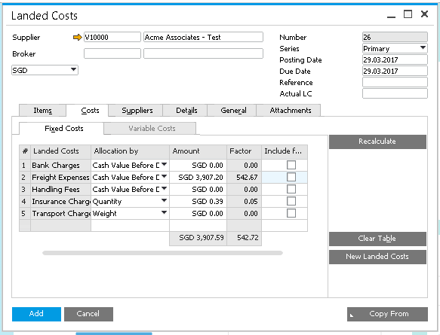

Method: Lump Sum (Scenario 1)
USD Exchange rate: 1.4

Spot Rate: 150 (Nothing to do with formula. Directly take the amount from Spot Rate udf).

 |  | After convert SGD
Freight | 150 | 150
Total Estimated Landed Cost to be created |  | 150

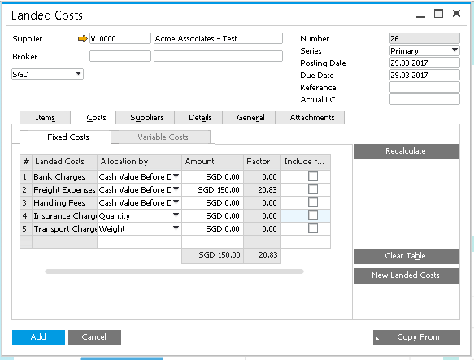

Reports

Report #1 – Landed Cost Contract Account Reconciliation Report

Column in reports:
BP | PO# | GRPO# | ALC  Required? | ELC# | ELC Amount  (Credit) | ALC# | AP  Inv # | Inv Amount  (Debit)

Requirement:
- This is report is for finance to do reconciliation for the landed cost.
- Finance has to input ELC no at AP Invoice line level match by PO no. if cancel invoice, finance to duplicate and amend accordingly.
- Filter by : BP Range, ELC #, PO#, ALC Required, Posting Date Range

ALC required is UDF from GRPO screen (OPDN.U_ALCRequired)
If cancel invoice/CN then show 2 lines (1 for Invoice and 1 for Cancel/CN)
If cancel GRPO then show 2 lines (1 for GRPO and 1 for cancel)

Report #2 – Landed Cost with COS account report

Column in reports:
BP | PO# | GRPO# | ALC  Required? | ELC# | ELC Amount  (Credit) | ALC# | AP  Inv # | Inv Amount  (Debit)

Requirement:
- This is report is for finance to pass JE by cost center for those ALC posted to Cost of good sold account.
- Finance has to input ELC no at AP Invoice line level match by PO no. if cancel invoice, finance to duplicate and amend accordingly.
- Filter by : BP Range, ELC #, PO#, ALC Required, Posting Date Range

Report #3 – Freight Percentage
To be confirmed: Is GRPO Value LC or FC if doc is FC?

Column in reports:
Forwarder/  Courier  Name | Weight | GRPO# | GRPO Amount | ELC-Freight  Charge | ELC Freight% | ALC# | ALC Freight Charge | Actual Landed Cost Amount | ALC% | AP Invoice#
 |  |  |  |  | ELC - Freight Charge / GRPO value * 100 |  |  | Total ALC | Total ALC / GRPO value * 100

Requirement:
- Filter by GRPO Date Range, Percentage above [>], Supplier Code Range, Forwarder Range.
- Show those with % above the given parameter.

